Name: Aryan Kalyan Bochare
Date: 7/10/2026
B.Sc,Data Science

Q1. consider the following table
STUDENT(Student_ID,Student_Name,Course_id,Marks)
COURSE(Course_ID,Course_Name,Fees
Write SQL queries to:
a) create the STUDENT table with Student_id as the primarry key.
b) Display student who have scored mothe than 70 marks
c)display student names along with their corresponding course names using a suitable Join.
d)Find the average marks for each Course_id using GROUP BY.
e) display only Course Whose average mark are greater than 65 using HAVING
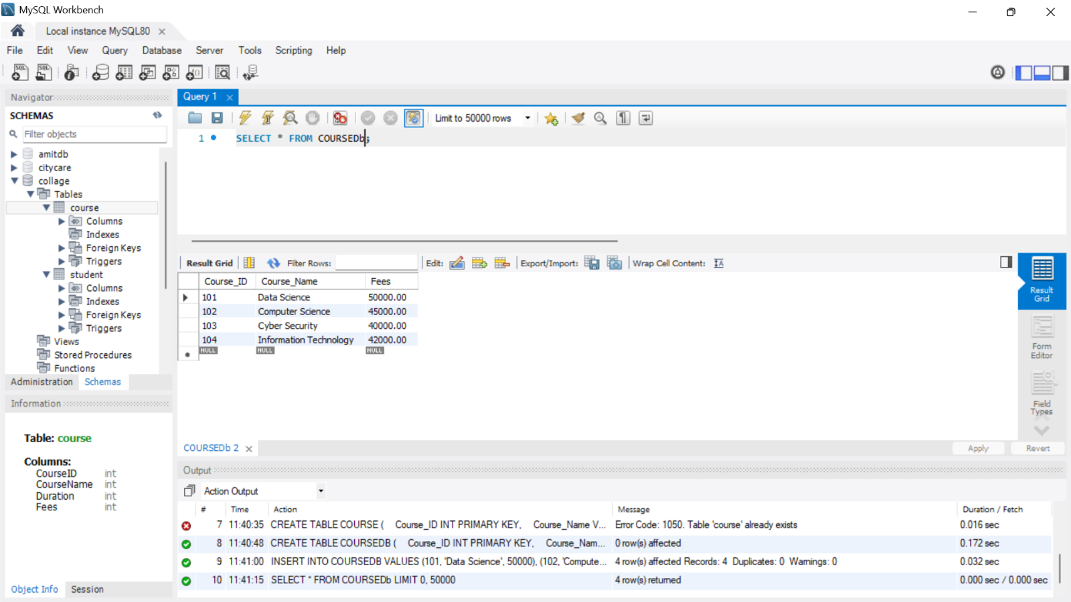
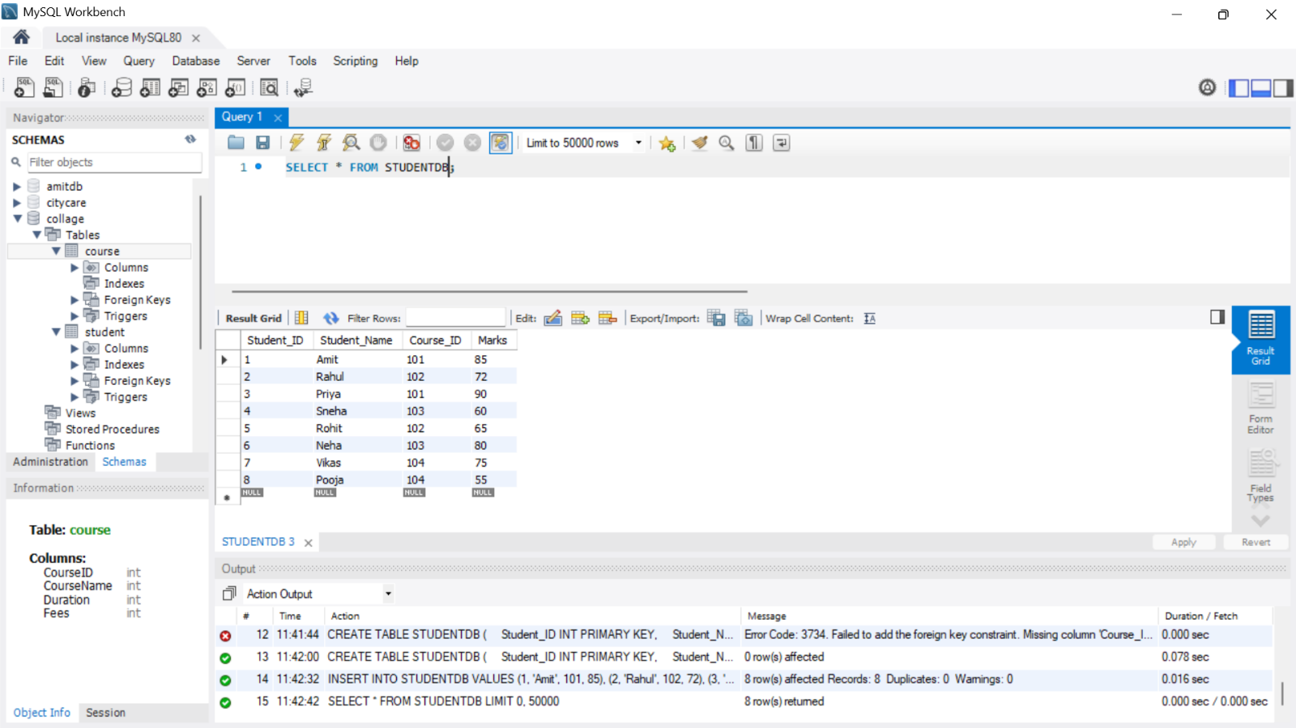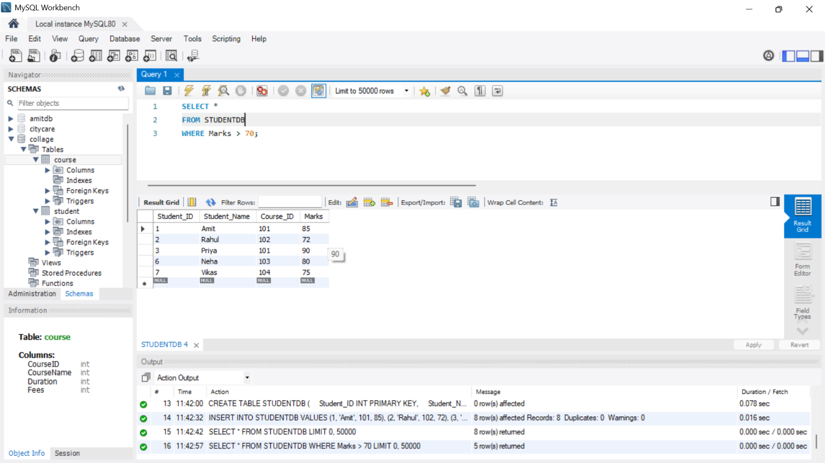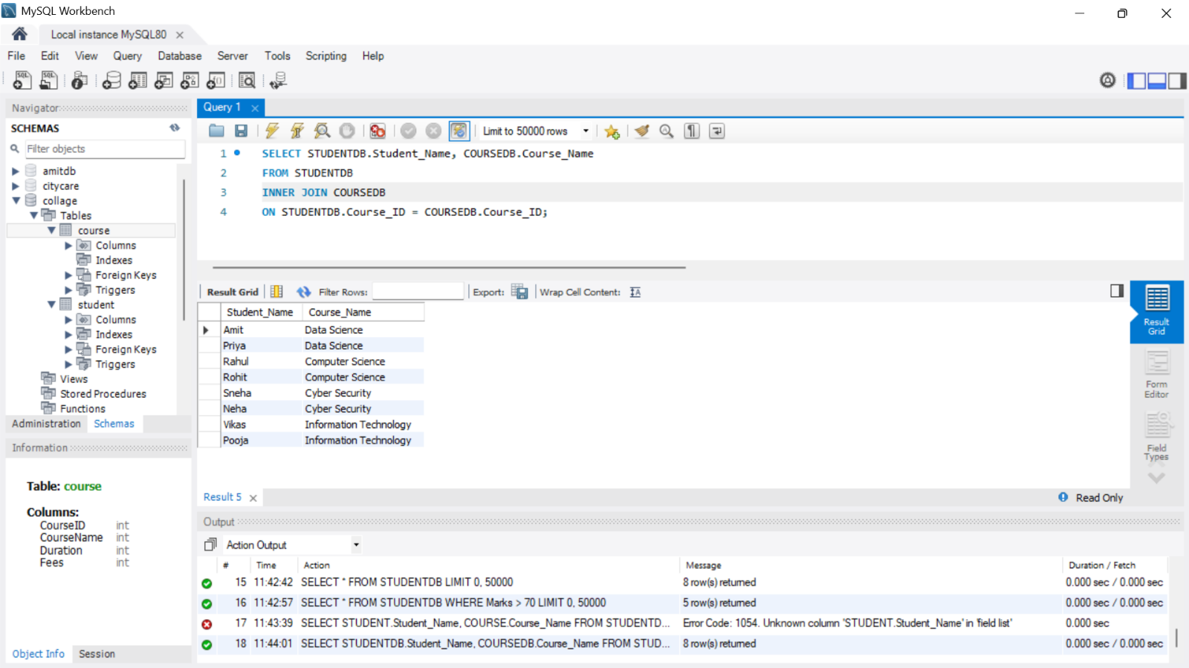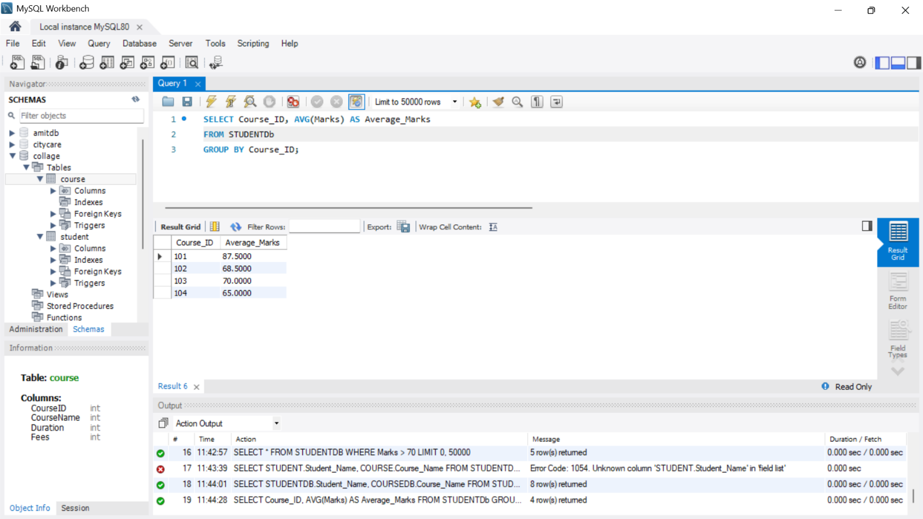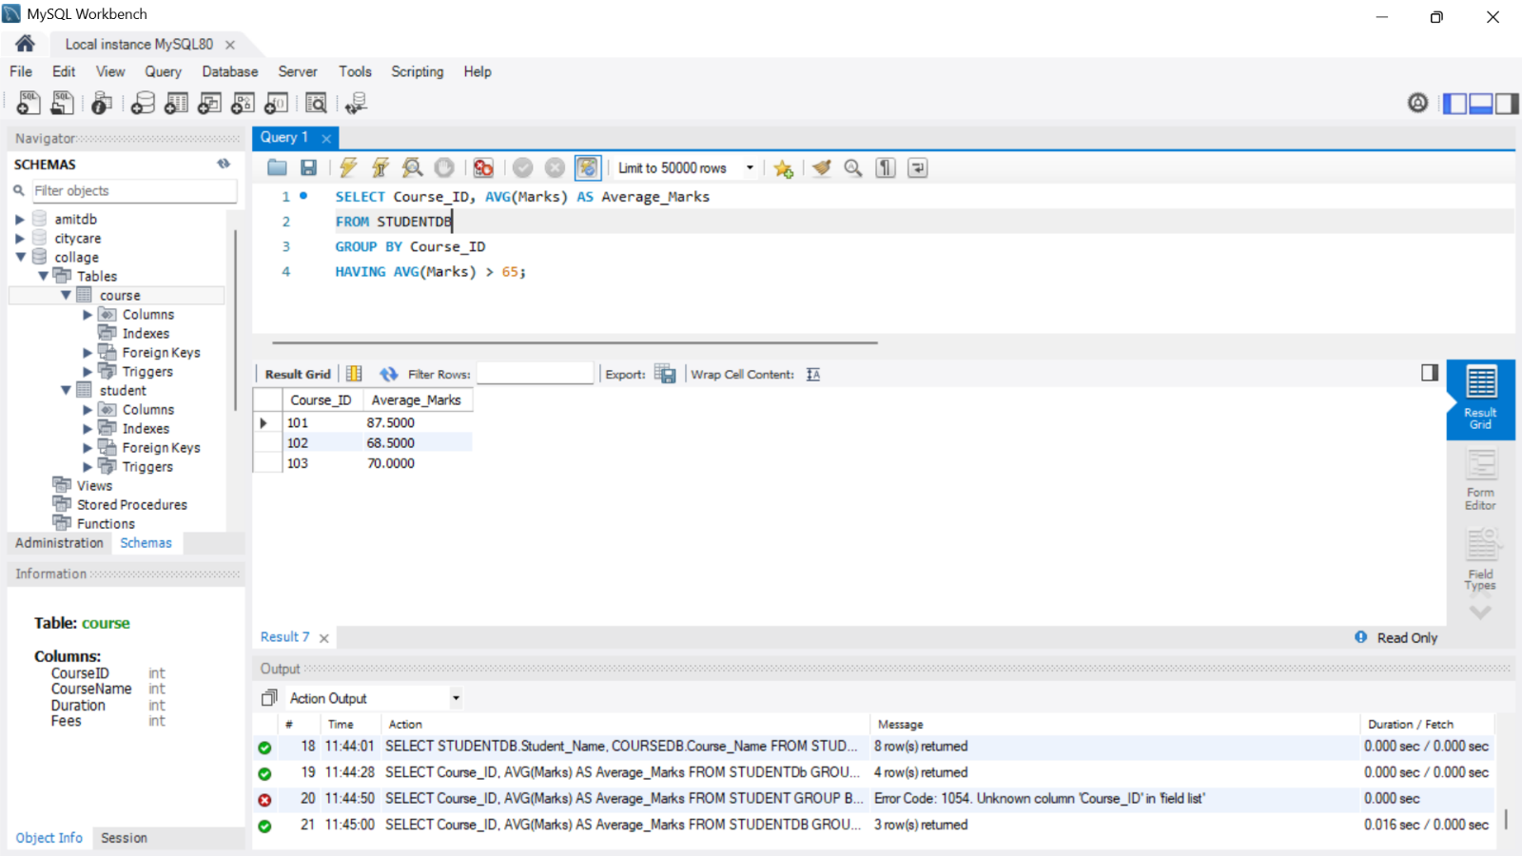

Q2. Consider the table:
EMPLOYEE(Emp_ID,Emp_Name,Department,Salary,Joining_Date)
Write queries to:
a) Display employees belonging to the IT department in descending order of salary
b) Display the highest salary in the table.
c)Display department having ,ore than 3 employees.
d)Display employees whose salary is greater then the avg salary of all employees using a subquery
e)Create a view named IT_Employees containing employees belonging to the IT department
